Our data transmission needs continues to prove itself as our biggest challenge as we are sending large amounts of data continuously. Our device was given the following requirements as an optimal operating mode:

1. Support up to 16 inter-cranial probes
2. Each inter-cranial probe has 16 electrodes
3. Each electrode outputs 8 bits, sampled at 16 bits due to Nyquist Frequency
4. Data sampled at 1 ksps
5. Send data over a range of at least 3m

Given the worse case scenario, our device will use 16 x 16 x 16 x 1 bits = 4Mbps. This is a lot of data to be transmitted in parallel, continuously every second. However after consulting with our PhD mentors, professors, and TI engineers, we concluded that our device could possibly work well with sending less data with a few techniques such as decimation, compression, and buffering. Instead of sending the full 4Mb, it would instead:

1. Each electrode outputs 8 bits, sampled at 16 bits but decimated back to 8 bits during transmission
2. Data sampled at 0.5 ksps instead of 1 ksps because most of the data is low frequency

This makes our worse case scenario a little bit better, as our device will use

16 x 16 x 8 x 0.5 = 1 Mbps. This is a 4x reduction in necessary bandwidth, which is much more reasonable and achievable. This reduction in bandwidth requirements before compression allows us to consider multiple wireless technology options and different network topologies[1]. A table of a few notable comparisons between technologies is listed:

|  |  |  |  |  |  |  |  |  |
| --- | --- | --- | --- | --- | --- | --- | --- | --- |
|  | Bluetooth Low Energy  (LE) | Wi-Fi | Radio Frequency for Consumer Electronics  (RF4CE) | ANT+ | Nike+ | Infrared  Data Association  (IrDa) | ZigBee | Near Field  Commu-nication  (NFC) |
| Cost | Low | High | Medium | Medium | Medium | Low | Low | Medium |
| Power  Efficiency | 0.153 μW/bit | 0.00525 μW/bit | <185.9 μW/bit | 0.71 μW/bit | 2.48 μW/bit | 11.7 μW/bit | 185.9 μW/bit | >185.9 μW/bit |
| Operating  Range | 100m | 150m | 100m | 30 m | 10 m | 10 cm | 100m | 5 cm |
| Throughput | 1 Mbps | 54 Mbps | ~424 kbps | ~20 kbps | ~20 kbps | ~1 Gbps | ~100 kbps | ~424 kbps |
| Latency | 2.5ms | 1.5ms | ~20ms | ~0 | ~1s | ~25ms | ~20ms | ~1s |
| Peak Current  Draw | ~ 12.5 mA | ~ 116 mA | ~ 40 mA | ~ 17 mA | ~ 12.3 mA | ~ 10.2 mA | ~45 mA | ~ 50 mA |

We also looked into network topologies and our research included the 5 main network topologies exist when discussing personal low-power radio networks:

1. Broadcast: A message is sent from a device in the hope that a receiver within range receives it. The broadcaster doesn't receive signals.
2. Mesh: A message can be relayed from one point in a network to any other by hopping through multiple nodes.
3. Star: A central device can communicate with a number of connected devices — Bluetooth is a common example.
4. Scanning: A scanning device is constantly in receive mode, waiting to pick up a signal from anything transmitting within range.
5. Point-to-Point: In this mode, a one-to-one connection exits, where only two devices are connected, similar to a basic phone call.

The wireless technologies we looked at can support the following network topologies as seen in figure 1.

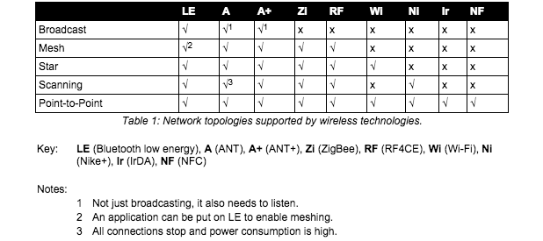

**Figure 1: Wireless Technology Network Topology**

There was another technology that we found called Ultra Wideband (UWB)[2], as seen in figure 2, that could have fulfilled all our needs and given us the 4 Mbps bandwidth that would have given us the most optimal performance but unfortunately the standard was abandoned due to in-fighting between competing factions. Unfortunately that puts UWB out of the running even though it had to potential to be a great wireless technology for our needs. Amongst the existing technologies, given that only Bluetooth Low Energy and Wi-Fi meet our throughput and operating range needs, we narrowed it down to those two technologies to weigh the pros and cons of the two. However, given that Wi-Fi has a high power draw, compute resources, and slightly higher cost, we decided to choose Bluetooth Low Energy as the wireless technology that we will focus on in creating our prototype due to the fact that is has great range, low power draw, and decent throughput at 1Mbps.

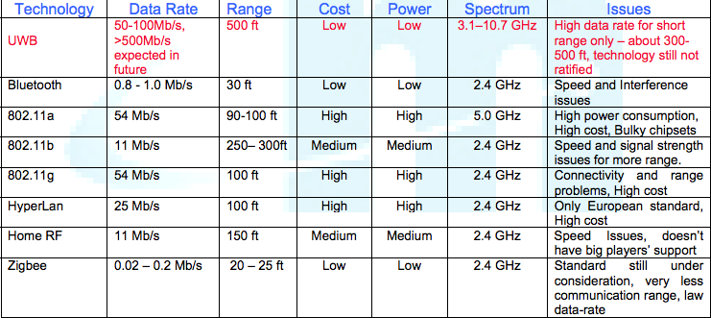

**Figure 2: UWB vs. BLE vs. Wi-Fi**

The Bluetooth radio interface has been designed to enable communications to be made reliably over short distances. The radio interface is relatively straightforward, although it has many attractive features. The Bluetooth radio interface supports a large number of channels and different power levels, as well as using reliable forms of modulation. Running in the 2.4 GHz ISM band, Bluetooth employs frequency hopping techniques with the carrier modulated using Gaussian Frequency Shift Keying (GFSK). With many other users on the ISM band from microwave ovens to Wi-Fi, the hopping carrier enables interference to be avoided by Bluetooth devices. A Bluetooth transmission only remains on a given frequency for a short time, and if any interference is present the data will be re-sent later when the signal has changed to a different channel, which is likely to be clear of other interfering signals. The standard uses a hopping rate of 1600 hops per second, and the system hops over all the available frequencies using a pre-determined pseudo-random hop sequence based upon the Bluetooth address of the master node in the network.

Bluetooth Low Energy shares some similarities with Classic Bluetooth. Both use the 2.4GHz spectrum. Basic Rate (BR) and BLE both use GFSK modulation at 1Mbps, but their modulation index is different. Enhanced Data Rate (EDR) uses a completely different modulation than GFSK. Classic Bluetooth has 79 channels compared to LE’s 40 channels. The channels are also spaced differently. Both of these differences make LE and Classic different and incompatible, so they can’t communicate to each other[3]. We can see the difference between Bluetooth Low Energy and Classic in Figure 3, with Bluetooth Low Energy being able to theoretically support our 1 Mbps bandwidth requirements.

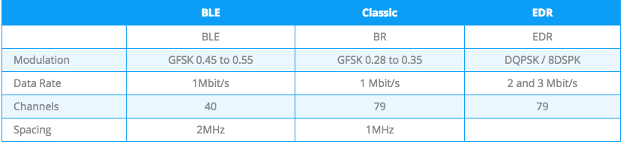

**Figure 3: Comparison Between BLE and Classic**

Bluetooth Smart has two ways of communicating. The first one is using advertisements, where a BLE peripheral device broadcasts packets to every device around it. The receiving device can then act on this information or connect to receive more information. The second way to communicate is to receive packets using a connection, where both the peripheral and central send packets. BLE Advertising is one of the most important aspects of Bluetooth Low Energy. This is seen, as a connection between two devices without using advertisements is impossible. Defining the data and format of advertisement packets is usually the first thing you work on when developing a BLE device. Also, a large number of BLE products sleep most of the time, waking up only to advertise and connect when needed. This means advertisements have a big impact on power consumption.

The 2.4GHz spectrum for Bluetooth extends from 2402MHz to 2480MHz, as seen in figure 3. LE uses 40 1MHz wide channels, numbered 0 to 39. Each is separated by 2MHz. Channels 37, 38, and 39 are used only for sending advertisement packets. The rest are used for data exchange during a connection. During BLE advertisement, a BLE Peripheral device transmits packets on the 3 advertising channels one after the other. A Central device scanning for devices or beacons will listen to those channels for the advertising packets, which helps it discover devices nearby.

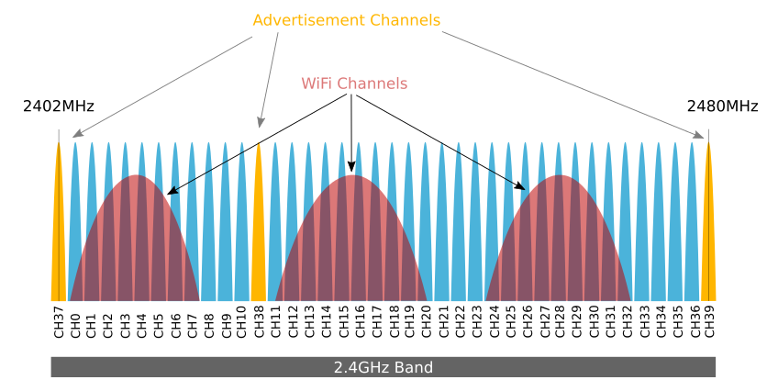

**Figure 3: Bluetooth Channels**

We researched and found that for Bluetooth Low Energy, the current stand is BLE 4.2, which is more power efficient and secure but Bluetooth v4.2 hasn’t made it yet to the market completely because it requires updated hardware and because it requires support on both sides of the link for transmitting and receiving. We also notice that most of the devices available are Single Mode only, and that most of those run v4.1 of the Bluetooth Specification, which is still new but well documented and still decently low power. We also noticed that dual Mode devices are not as popular because of cost and the complexity of supporting Bluetooth Classic and BLE on the same chip.

Looking into the current vendors and existing chipsets, we found a large variety of options ranging from Bluetooth 4.0 to Bluetooth 4.1. There are also variations of processors, ranging from fast to faster and variations in the amount of memory, and power draw. This is evident in figure 4, where a list of competing chips with their processors, memory, and power drawn is compared[4].

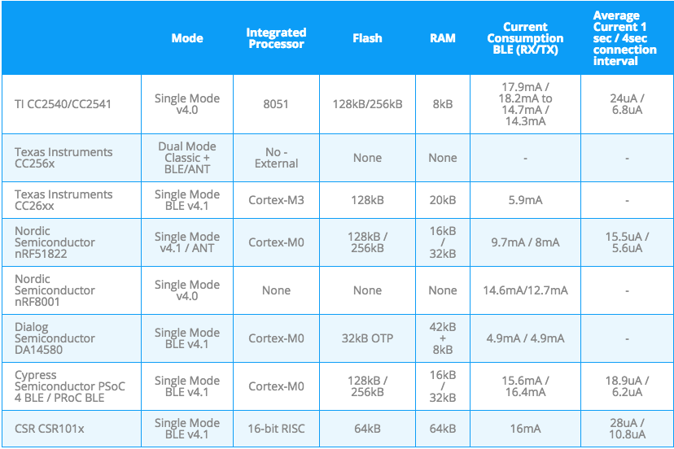

**Figure 4: Comparison of BLE Chips**

Given the comparison, we found Nordic Labs and Texas Instruments to have very reasonable options that could fit our needs in terms of integrated processor, flash, and RAM. We did more research into Nordic Lab’s offerings and found they had a newer chip that could compete with the TI CC2650, that we determined to be a finalist in our short-list of chips. Nordic Lab’s new nRF52 actually has better stats than TI’s top of the line CC2650, as we can see in figure 5[5].

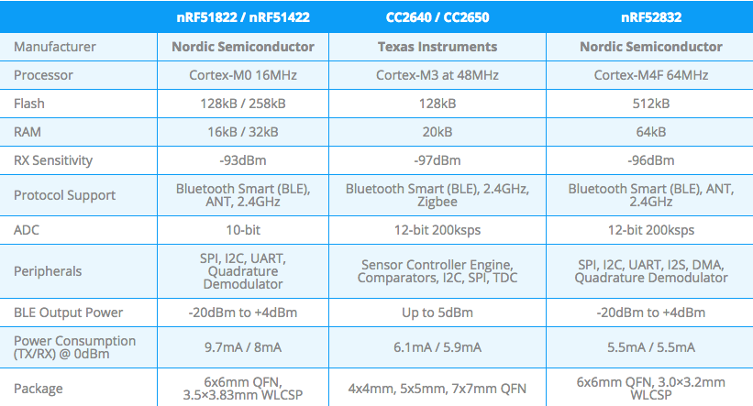

**Figure 5: Texas Instruments vs Nordic Labs**

We can see that the Nordic Lab’s nRF52 beats out the TI CC2650 by quite a margin, however it is still preview hardware without as much documentation. We also determined that the TI CC2650 would be a better design choice as we get sponsorship from TI and have more access to their engineers for clarifying questions. In the end, we chose the TI CC2650 chip as the chip that would power the wireless technology behind our prototype given its low power consumption, package size, fast processor, and great technical support.

1. <http://www.digikey.com/en/articles/techzone/2011/aug/comparing-low-power-wireless-technologies>
2. <http://wireless.fcc.gov/outreach/2004broadbandforum/comments/ultrawideband.pdf>
3. <http://www.argenox.com/bluetooth-low-energy-ble-v4-0-development/library/a-ble-advertising-primer/>
4. http://www.argenox.com/bluetooth-low-energy-ble-v4-0-development/library/a-guide-to-selecting-a-bluetooth-chipset/
5. <http://www.argenox.com/blog/nordic-announces-new-line-of-cortex-m4-ble-socs/>